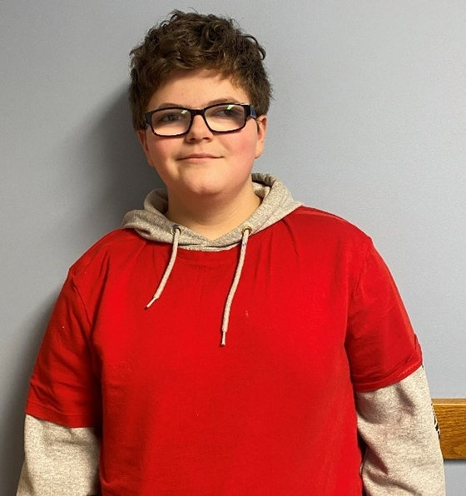
Kingston is a 14-year-old male. Kingston has a large personality and is an entertainer at heart. Kingston enjoys rapping, dancing, and making others laugh. Kingston loves to listen to music and his favorite genre is rap. Kingston has expressed interest in wrestling, basketball, and karate. Kingston’s favorite color is red. Kingston ‘s favorite holiday is Halloween because he can trick or treat and get candy. Kingston can often be found crafting and coloring. Kingston enjoys riding his bike outside and learning about healthier lifestyle habits.
Kingston has experienced a lot of traumatic events in his life which have led to the needs that he has today. Kingston attends public school where he is in the general education classroom while getting additional accommodations. Kingston has an Individual Educational Plan. Within this plan, the school ensures that they meet all his educational needs. Kingston does well in school with his accommodations. Kingston’s favorite subject is math, and he really enjoys the staff at his current school. It has been suggested that Kingston would do best in a two-parent home with structure and consistency.
Kingston thrives in an environment that is patient, kind, outgoing, and optimistic. Kingston receives supportive services as well as working with mental health and educational providers to ensure that all his special needs are met. Kingston will need support and commitment in following through with recommendations that are made for him. If you are interested in learning more about Kingston, we look forward to hearing from you.
More Information Contact:
Muskingum County Adult and Child Protective Services
205 N 7th St Zanesville, OH 43701
Contact: Tammy McGregor
Telephone: 740-455-6710

