Muskingum County
Senior Resource Guide

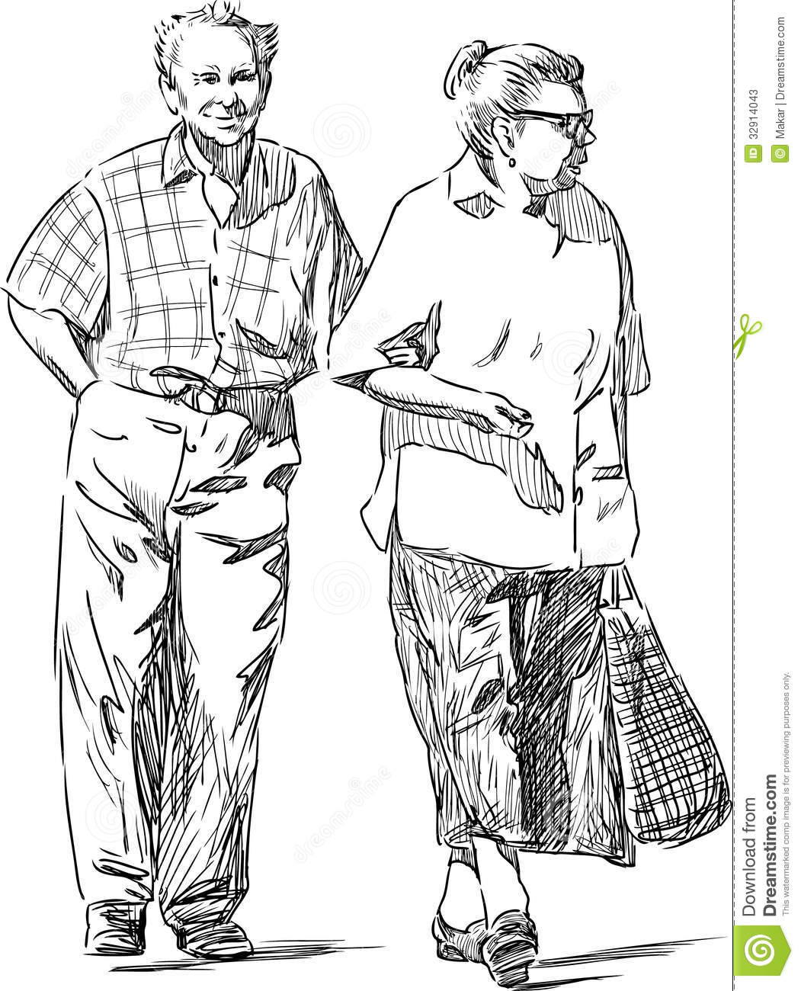

FREQUENTLY USED PHONE NUMBERS
DOCTORS, FAMILY MEMBERS, NEIGHBORS, ETC.

Table of Contents

Activity Centers  Adult Support Systems  Advocates | 1
Advocates continued  Emergency Assistance  Food Assistance | 2
Food Assistance continued  Clothing Assistance  Financial Management Assistance  Health Services – Alcohol/Drug | 3
Health Services – Alcohol/Drug continued  Health Services – Environmental Health  Health Services – Medical Health  Health Services – Mental Health | 4
Home Repair Assistance  Housing – Assisted Living  Housing – Financial Assistance for Assisted Living  Housing – Boarding Homes  Housing – Emergency Shelter | 5
Housing continued  Housing – Independent Living Information  Legal Assistance  Medical Equipment  Nursing Homes | 6
Nursing Homes continued  Palliative Care  Pharmacies  Public Assistance  Respite Care | 7
Transportation  Managed Care Plans that May Help  Utility/Tax Reduction Assistance  Veterans’ Assistance | 8

Senior Resource Guide – Muskingum County

Activity Centers
Alfred S. Carr Center… (Adult Day Care)…1035 Beverly Ave., Zanesville, OH…740.453.5417
Bonnie Longaberger Senior Center…1348 Main St., Dresden, OH…740.754.1436
John McIntire Public Library…220 N 5th St., Zanesville, OH …740.453.0391
Muskingum County Center for Seniors…160 N 4th St., Zanesville, OH…740.454.9761
Muskingum County Senior Services…1118 W Main St., Zanesville, OH…740.452.0984

Adult Support Systems
Area Agency on Aging Region 9, Inc…1730 Southgate Parkway, Cambridge, OH 1.800.945.4250
Bureau of Services for Visually Impaired…601 Underwood St., Zanesville, OH…740.453.0673
Muskingum County Center for Seniors…160 N 4th St., Zanesville, OH…740.454.9761
Muskingum County Adult Child Protective Services…1830 East Pike, Zanesville, OH…740.452.6339
REFERRALS 740.455.6710
Muskingum County Board of MR/DD…1304 Newark Rd., Zanesville, OH…740.453.4829
Muskingum County Job and Family Services…445 Woodlawn Ave., Zanesville, OH…740.454.0161
Social Security Office for Zanesville…3823 James Court, Zanesville, OH 1.855.884.3408
OSHIIP (Ohio Senior Health Insurance Information Program of the Ohio Department of Insurance…1.800.686.1578

Advocates
Crime Victim Assistance Program…1730 Southgate Pkwy, Cambridge, OH…800.945.4250
KEPRO…2029 Riverside Dr. Ste 204, Columbus, OH…614.929.3990
Led by the Centers for Medicaid & Medicare Services (CMS) dedicated to improving health quality at the local level. KEPRO offers information assistance to providers, patients and families regarding beneficiary complaints, discharge appeals and immediate advocacy.

Advocates Continued
Long-Term Care Ombudsman…821 Anola Ave Suite D., Dover, OH….330.364.3464/800.976.0615
Helps individual negotiate the complaint and appeal process. Serves as a voice for residents of nursing homes, residential and adult care facilities and consumers of in-home services.
Transitions (domestic violence) …740.454.3213
Victim’s/Witness Assistance…Zanesville City Hall…401 Market St., Zanesville, OH…740.455.0601

Emergency Assistance
Life Threatening Emergencies…911
Genesis Community Ambulance Service…952 Linden Ave., Zanesville…740.454.6800
Muskingum County Coroners Office…2215 Adamsville Rd., Zanesville…740.455.8243
Muskingum County Sheriff Office… 1830 East Pike, Zanesville, OH…740.452.3637
State Highway Patrol…3760 East Pike, Zanesville, OH…740.453.0541
Zanesville Fire Department…332 South Street 1, Zanesville, OH…740.455.0700
Zanesville Police Department…332 South Street, Zanesville, OH…740.455.0700

Food Assistance
Hot Meal Service
Bonnie Longaberger Senior Center…1348 Main St., Dresden, OH…740.454.9761
Christ Table….28 S 6th St., Zanesville, OH…740.452.9766
Muskingum Co Center for Seniors…160 N 4th St., Zanesville, OH…740.454.9761
Salvation Army…515 Putnam Ave., Zanesville, OH 740.452.8350
Lunch: M-F (11:30) Bonnie Longaberger 1348 Main St., Dresden, OH 740.454.9761
Lunch: M-F (11:00-1:00) Christ Table 28 S 6th St., Zanesville, OH 740.452.9766
Lunch: Saturday (10:30-12:30) Christ Table 28 S 6th St, Zanesville, OH 740.452.9766
Lunch: M-F (11:15) Muskingum Co Center for Seniors 160 N 4th St., Zanesville, OH 740.454.9761

Food Assistance Continued
Dinner: M-F (4:00-5:30) Salvation Army 515 Putnam Ave., Zanesville, OH 740.452.8350
Sunday Dinner: (5-5:45) Fellowship of Christ Community Central Presbyterian Church 40 N 6th St., Zanesville, OH 740.452.8549

Home Delivered Meal Program
Christ Table….28 S 6th St., Zanesville, OH…740.452.9766
Franciscan Community Action Agency Meals on Wheels…828 Lee St., Zanesville, OH 740.453.5703
Mom’s Meals…1.877.508.6667
Muskingum Co Center for Seniors…160 N Fourth St., Zanesville, OH 740.454.9761

Pantry
Christ Table…28 S 6th St., Zanesville, OH…740.452.9766
East Side Community Ministry…221 Stillwell St., Zanesville, OH 740.452.7519 (must be assigned)
Salvation Army…515 Putnam Ave., Zanesville, OH…740.452.8350
Pathways of Central Ohio… 211/1.800.544.1601 (for information about the nearest food pantry to your home)

Clothing Assistance
Eastside Community Ministry…221 Stillwell St., Zanesville, OH… 740.452.7519
Pathways of Central Ohio… 211/1.800.544.1601
The Salvation Army…515 Putnam Ave., Zanesville, OH…740.452.8350

Financial Management Assistance
Catholic Social Services…45 N 4th St., Zanesville, OH… 740-452-5057

Health Services
Alcohol/Drug
Alcoholic Anonymous…1.800.870.3795
Narcotic Anonymous…1.818.773.9999
Cedar Ridge Behavioral Health Solutions…5999 Raiders Rd., Frazeysburg, OH…855.692.7247 (Inpatient) (Open Spring 2017) (Medicaid/Medicare)
Cedar Ridge Behavioral Health Solutions…301 Main St. Suite I, Zanesville, OH…855.692.7247 (Outpatient) (Medicaid/Medicare)
Genesis Outpatient Behavioral Health…2951 Maple Ave., Zanesville, OH….740.454.5927

Health Services Continued
Mental Health and Alcohol Recovery Services Board…1205 Newark Rd., Zanesville, OH….740.454.8557
Muskingum Behavioral Health… 601 Underwood St., Zanesville, OH…740.454.1266
Pickaway Area Recovery Services…2811 Maysville Pike, Zanesville, OH…740.487.1474 (women only: Medicaid/Medicare) (Inpatient)

Environmental Health
City of Zanesville Building and Code Enforcement….401 Market St., Zanesville, OH …740.455.0601
Zanesville Muskingum County Health Department…205 N.7th St., Zanesville, OH….740-454-9741

Medical Health
Genesis Healthcare Center…2951 Maple Ave., Zanesville, OH…740.455.4949 (nurse line)
Genesis Hospice…713 Forest Ave., Zanesville, OH…740.454.5365
Genesis Palliative Care…945 Bethesda Dr. Suite 120 Zanesville, OH…740.455.4925
Muskingum County Veterans Services…225 Underwood St.,… Zanesville, OH…740.455.7149
Muskingum Valley Health…719 Adair Ave., Zanesville, OH…740.455.5151
Rambo Memorial Health Centers…711 Main St., Zanesville, OH …740.452.5401
Zanesville Muskingum County Health Department…205 N 7th St., Zanesville, OH…740.454.9741
Zanesville Veterans Administration Community Based Outpatient Center…2800 Maple Ave., Zanesville, OH …740.453.7725

Mental Health
Allwell… 2845 Bell St., Zanesville, OH…740.454.9766
Crisis Hotline…740.453.5818 and/or 1.800.344.5818
Genesis Behavioral Health…2951 Maple Ave., Zanesville, OH… 740.454.4778
Mental Health and Alcohol Recovery Services Board…1205 Newark Rd., Zanesville, OH…740.454.8557
Zanesville Veterans Administration Community Based Outpatient Center…840 Bethesda Dr., Zanesville, OH …740.453.7725

Home Repair Assistance
Area Agency on Aging Region 9…1730 Southgate Parkway, Cambridge, OH…800.945.4250
Kiwanis…PO Box 745 Zanesville, OH 43702 (wheel chair ramp project- write to ask for application)
Muskingum County Community Action…828 Lee St., Zanesville, OH…453.5703
Muskingum County Community Development Office Zanesville, OH…740.455.7193
Muskingum County Senior Services 1118 W Main St., Zanesville, OH…740.452.0984
Zanesville City Community Development….740.455.0601

Housing
Assisted Living
Abbot Home…1258 Greenwood Ave., Zanesville, OH… 740.453.2781
Appletree Homes of Dresden…639 Cass St., Dresden, OH…740.754.1599
Brookdale Senior Living…1575 Bowers Ln., Zanesville, OH…740.450.9999
Clay Gardens Place…3784 Frazeysburg Rd., Zanesville, OH…740.450.2744
Helen Purcell…1854 Norwood Blvd., Zanesville, OH…740.453.1745
Primrose Retirement Community…4212 N Pointe Dr., Zanesville OH…740.450.1100

Financial Assistance for Assisted Living
Passport-Waiver Program…844.945.4250
Wartime veteran and/or surviving spouse may be entitled to financial assistance… 1.800.835.1541

Boarding Homes
Hollis Bailey….740.584.2822
TLC Acres…3394 Dresden Rd., Zanesville, OH….740.453.3176

Emergency Shelter
Crisis Stabilization…3405 Dillon Acres, Zanesville, OH…740.455.4132 (mental health)
Pierce Street Community Center…857 Putnam Ave., Zanesville, OH …740.452.0858
Salvation Army (3pm-10am)…515 Putnam Ave., Zanesville, OH…740.452.8350
Transitions (domestic violence shelter)…740.454.3213

Housing Continued
Independent Living Information
Contact: Muskingum County Center for Seniors….160 N 4th St., Zanesville, OH …740.454.9761

Legal Assistance
Ohio Attorney General…614.466.4986…1.800.252.0515
Pro Senior Legal Hotline…800.488.6070
Southeastern Ohio Legal Services…12 W. Locust St., Newark, OH…740.345.0850 and/or 1.888.831.9412

Medical Equipment
Apria…120 Sunrise Center, Zanesville, OH…740.452.0645
American Homepatient…965 Linden Ave., Zanesville, OH…740.455.3001
Lincare…1218 Brandywine Blvd., Zanesville, OH…740.452.2502
Med-OX…1080 Linden Ave., Zanesville, OH…740.454.6550
Northside Oxygen and Medical Equipment…702 Wabash Ave., Zanesville, OH…740.453.0693
Shrivers Pharmacy…406 Brighton Blvd., Zanesville, OH…740.452.3691

Medical Equipment Loans
Alfred S Carr Center…1035 Beverly Ave., Zanesville, OH…740.453.5417
Hope to the Rescue…38 N 4th St., Zanesville, OH…740.252.9518
Muskingum County Center for Seniors…160 N 4th St., Zanesville, OH…740.454.9716

Nursing Homes
Brookdale Senior Living has a memory center…1575 Bowers Lane , Zanesville, OH…740.450.9999
Helen Purcell has a memory center…1854 Norwood Blvd., Zanesville, OH…740.453.1745
Adams Lane Care Center…1856 Adams Lane, Zanesville, OH…740-454-9769
Beckett House of New Concord…1280 Friendship Dr., New Concord, OH…740.872.0809
Cedar Hill Care Center…1136 Adair Ave., Zanesville, OH…740.454.6823
(The) Oaks at Bethesda…2971 Maple Ave., Zanesville, OH …740.452.3800
(The) Oaks at N Pointe…3291 Northpointe Dr., Zanesville, OH…740.452.3000
Ohio Veterans Home…3416 Columbus Ave., Sandusky, OH…419.625.2454
Willow Haven Care Center…1020 Taylor St., Zanesville, OH…740.454.9747
Nursing Homes Continued
Zandex Health Care Corporation (main office)…1122 Taylor St., Zanesville, OH…740.454.1400
Zanesville Health and Rehabilitation Center…1420 Autumn Dr., Zanesville, OH…740.452.4351
Palliative Care
Genesis Palliative Care…945 Bethesda Dr., Zanesville, OH…740.455.4925

Pharmacies
CVS…1208 Maple Ave., Zanesville, OH…740.453.3442
CVS…103 N Maysville Ave., Zanesville, OH…40.452.7589
Johnstons…26 E 3rd St., Frazeysburg, OH…740.828.2601
Kroger…3387 Maple Ave., Zanesville, OH…740.453.8837
Lawlers…817 Main St., Dresden, OH…740.754.3434
Northside…10 E Main St., New Concord, OH…740.826.4000
Northside…157 S Main St., Roseville, OH…740.697.0348
Northside (Bethesda Pavilion)…945 Bethesda Dr., Zanesville, OH…740.454.4044
Northside (MAB3)…751 Forest Ave., Zanesville, OH…740.454.6970
Northside (Muskingum Valley Health)…716 Adair Ave., Zanesville, OH…740.868.8171
Northside-North…2899 Bell St., Zanesville, OH…740.453.0508
Northside-South…15 N Maysville Pike, Zanesville, OH…740.453.3700
Riesbeck-South…2200 June Pkwy., Zanesville, OH…740.450.7859
Rite Aide…825 Main St., Zanesville, OH…740.452.5485
Sam’s Club…3724 Northpointe Dr., Zanesville, OH…740.452.6869
Walgreens…1033 Military Rd., Zanesville, OH…740.588.0690
Walmart-North…2850 Maple Ave., Zanesville, OH…740.455.9007
Walmart-South…2850 Maysville Pike, Zanesville, OH…740.452.2117

Public Assistance
Muskingum County Job and Family Services…445 Woodlawn Ave., Zanesville, OH…740.454.0161
Respite Care
Alfred Carr Center (Adult Day Care)…1035 Beverly Ave, Zanesville, OH…740.453.5417
Area Agency on Aging Region 9…1730 Southgate Parkway, Cambridge OH…1.844.932.7277
Genesis Hospice and Palliative Care…713 Forest Ave, Zanesville, OH…740.454.5365
Hope to the Rescue…38 N 4th St., Zanesville, OH…740.252.9518
Transportation
Managed Care Plans Might be able to help with this:
- Buckeye Community Health…1/866.246.4358
- CareSource…1.800.488.0134
- Molina Healthcare of Ohio…1/800.642.4168
- Paramount Advantage…1.800.462.3589
- Selection Services…1.800.324.8680
- United Healthcare Community Plans of Ohio, Inc…1.800.895.2017
Genesis Community Ambulance Service…952 Linden Ave., Zanesville, OH…740.454.6800
Muskingum County Center for Seniors …160 N 4th St., Zanesville, OH…740.454.9761
Muskingum County Job and Family Services…445 Woodlawn Ave., Zanesville, OH…740.454.0161
Muskingum County Veteran Services…225 Underwood St., Zanesville, OH …740.455.7149
South East Area Transit…224 Main St., Zanesville, OH…740.454.8573
Starbright Cab Company-Zanesville, OH…905 Goddard Ave., Zanesville, OH…740.453.3882

Utility /Tax Reduction Assistance
City of Zanesville Utilities (water department)…401 Market St., Zanesville, OH…740.455.0601 (60+)
Muskingum County Community Action…828 Lee St., Zanesville, OH…740-453-5703
Muskingum County Homestead and Tax Reduction…401 Main St., Zanesville, OH…740.455.7109 (65+)
Muskingum County Senior Services…1118 W Main St., Zanesville, OH…740.452.0984 (55+)
Muskingum County Veteran Services…225 Underwood St., Zanesville, OH …740.455.7149 (veterans and/or surviving spouses of veterans)

Veterans’ Assistance
Muskingum County Veteran Services…225 Underwood St., Zanesville, OH…740.455.7149
VA Crisis Hotline….1.800.273.8255
Zanesville Veterans Administration Community Based Outpatient Center…2800 Maple Ave., Zanesville, OH…740.453.7725

Vial of Life Tips

5 Simple Tips That Could Save Your Life
- Fill out the Vial of Life medical information.
- Place completed form in the Vial of Life sealing bag and place in the top shelf of your refrigerator door.
- Place the provided Vial of Life magnet or sticker on the upper corner of your refrigerator AND on the main door of your residence.
- Make additional copies of your Vial of Life to carry with you or in your vehicle.
- Make it a habit to review and update your Vial of Life when you change your clocks.

VIALS CAN BE PICKED UP AT THE MUSKINGUM COUNTY CENTER FOR SENIORS – CORNER OF 160 N. 4TH STREET– ZANESVILLE, OHIO 740-454-9761

Resource Guide created by the Muskingum County Interdisciplinary Team
Allwell Behavioral Health Services Area Agency on Aging Region 9
Genesis Community Ambulance Genesis Hospice
Genesis Healthcare System/ Drug & Alcohol Recovery
Genesis INPT Care Management Mideast Career Technology Center
Muskingum Behavioral Health Muskingum County Center for Seniors
Muskingum County Adult and Child Protective Services
Muskingum County Coroner’s Office Muskingum County Fireman’s Association
Muskingum County Job & Family Services Muskingum County Sheriff’s Office
Muskingum County Prosecutor’s Office
Muskingum Valley Health Center Seaton Housing
Transitions Zanesville Community Based Outpatient Clinic- Veterans Affairs Zanesville Fire Department
Zanesville Muskingum County Health Department Zanesville Police Department

