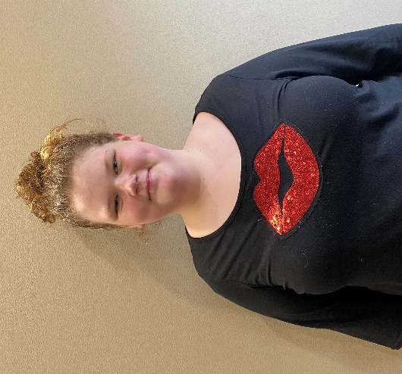
Kaydence
(DOB May 2008)
Age: 15
Kaydence is a 15-year-old female. Kaydence is outgoing and eager to make friendships. Kaydence is optimistic on her future and plans to have her own family where she can be a "positive influence". Kaydence has an interest in becoming a nurse. Kaydence enjoys reading, writing, history, and painting. Kaydence has a passion for dogs and helping others. Kaydence’s favorite color is pastel yellow and pink. Kaydence loves to listen to country music. Kaydence has a love for her community and a desire to do more volunteer work.

Kaydence has experienced a lot of traumatic events in her life which have led to the needs she has today. Kaydence attends public school where she is in the general education classroom. Kaydence does not have an Individual Educational Plan. Kaydence enjoys school and all the subjects it involves but specifically history. Kaydence has several friends at school that she would consider to be positive friendships. It has been suggested that Kaydence would do best in a one or two parent home with structure and consistency.

Kaydence thrives in an environment that is patient, structured, outgoing, and optimistic. Kaydence is goal oriented and enjoys staying busy. Kaydence receives supportive services such as individual counseling and medication management. These are services that would need to continue in her prospective adoptive home. If you are interested in learning about Kaydence, we look forward to hearing from you.
More Information Contact:

Agency:
Muskingum County Adult and Child Protective Services
205 N 7th St Zanesville, OH 43701
Contact: Lynsey Yarger
Telephone: 740-455-6710 Ext. 402
Email: Lynsey.Yarger@jfs.ohio.gov

